

Group Assignment
SolidWorks CAD Design of a Quadcopter Drone
Aerospace Department
Subgroup 5

SolidWorks CAD Design of a Quadcopter Drone

Components included under this design

- Frame of the Quadcopter Drone
- Four arms
- Motor mounting plates
- landing skids
- Battery mounting tray
- Electronic component mounting plate ( only distance senser included )
- Fasteners: screws, nuts, and bolts
- Four brushless DC (BLDC) motors design
- Four propellers
- Motor mounts
- Battery in design level
- Propeller nuts
- Camera which has more than for degree of freedom
- An additional more than 30 individually designed components not shown in this image, are included in the complete drone assembly

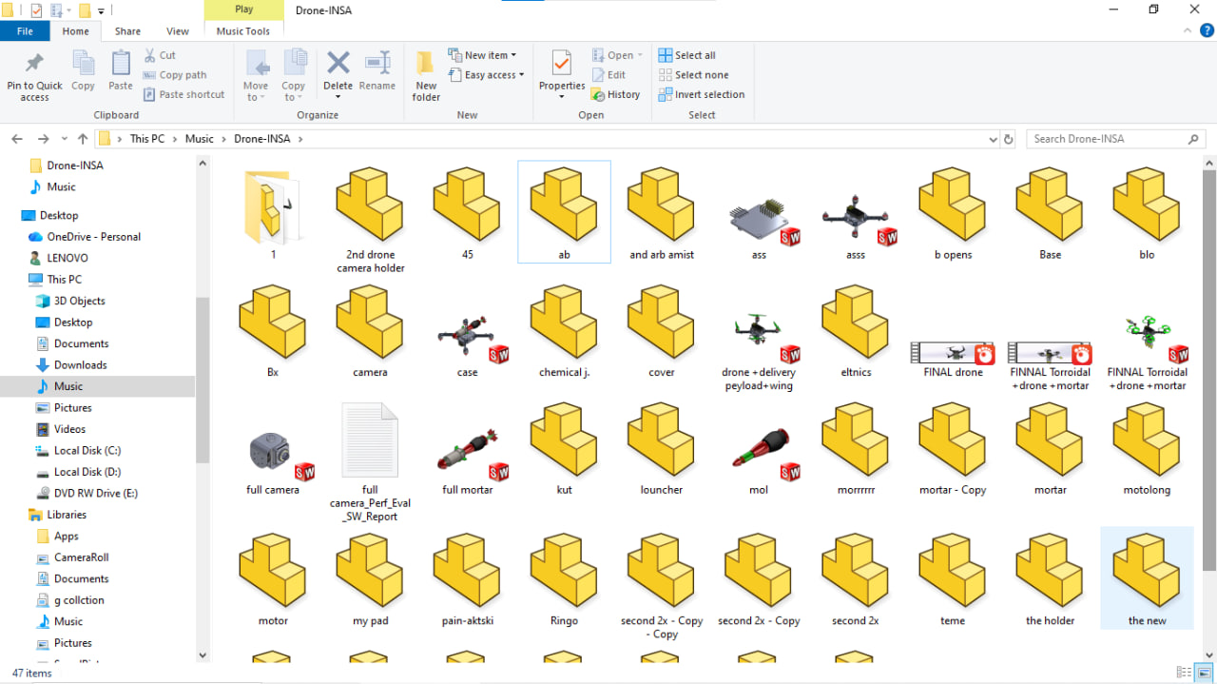
Figure 1.1

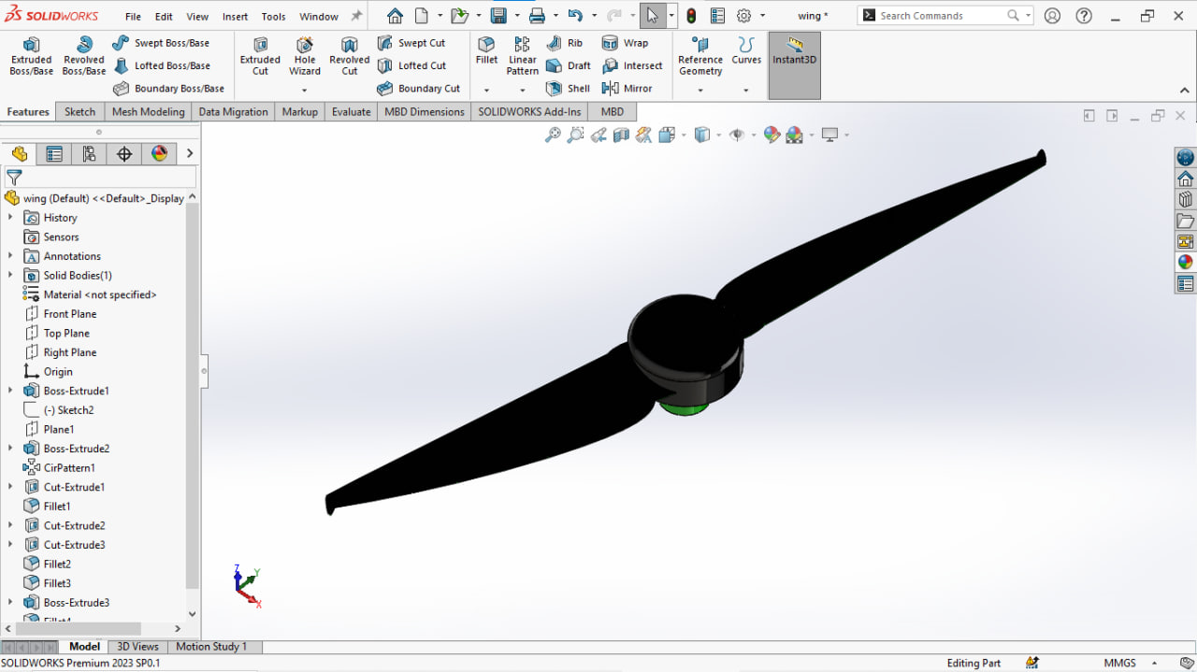
Figure 1.2

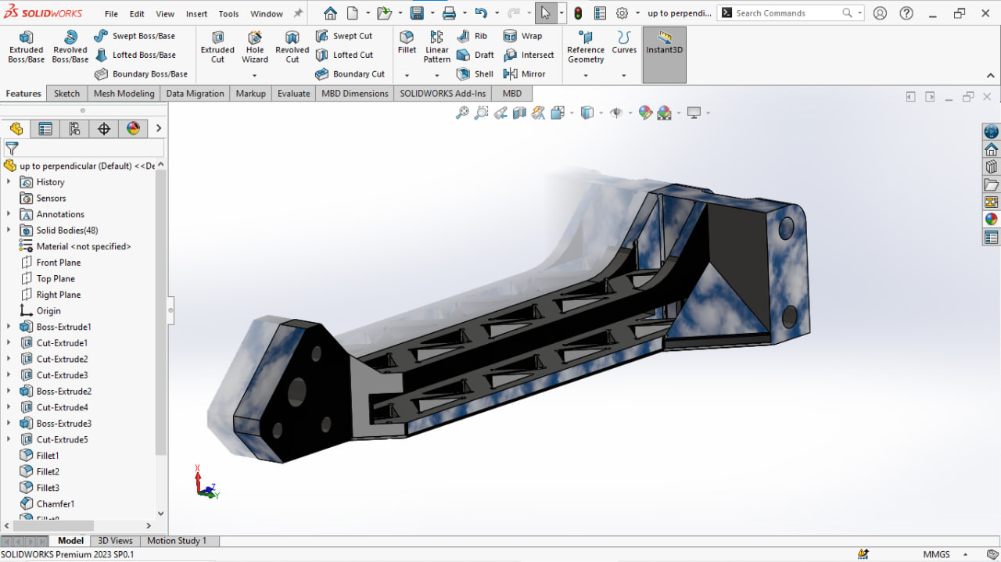
Figure 1.3

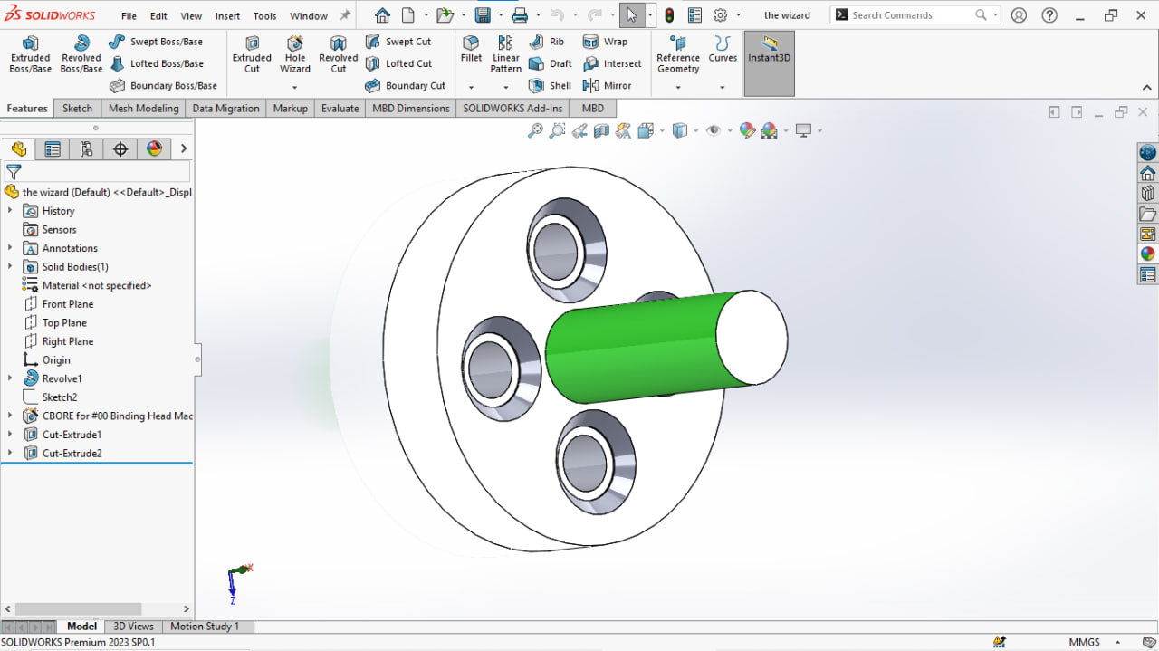
Figure 1.4

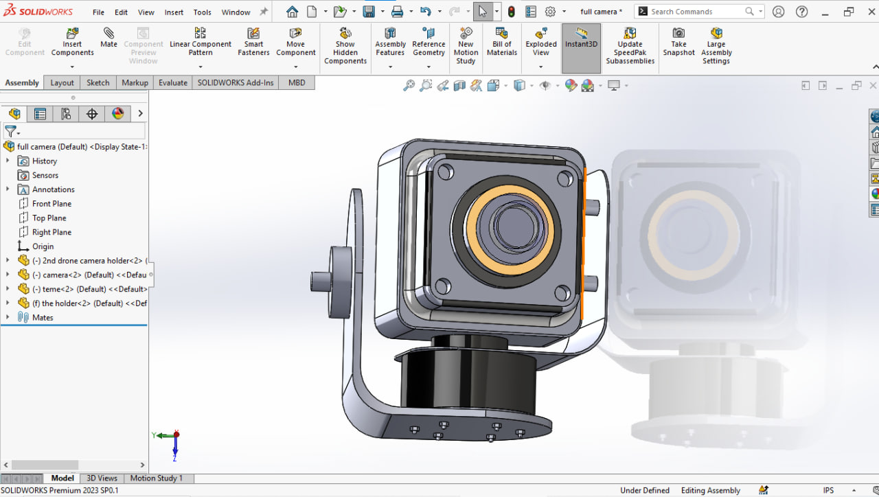
Figure 1.5

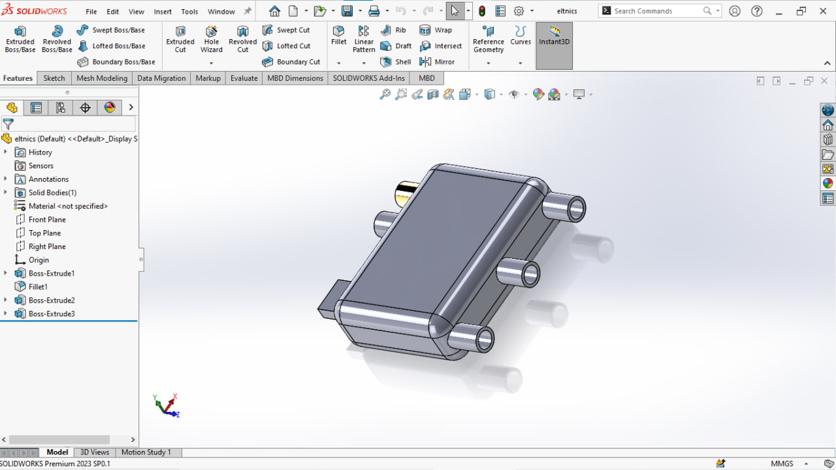
Figure 1.6

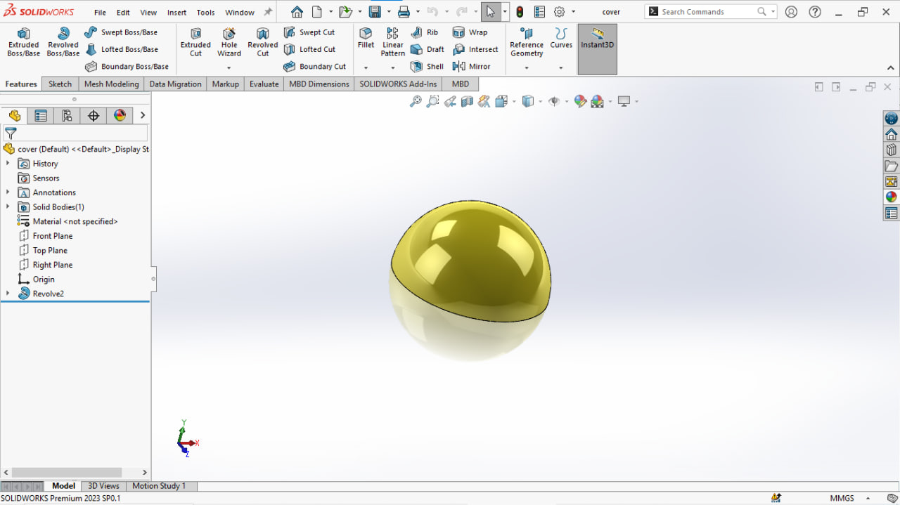
Figure 1.7

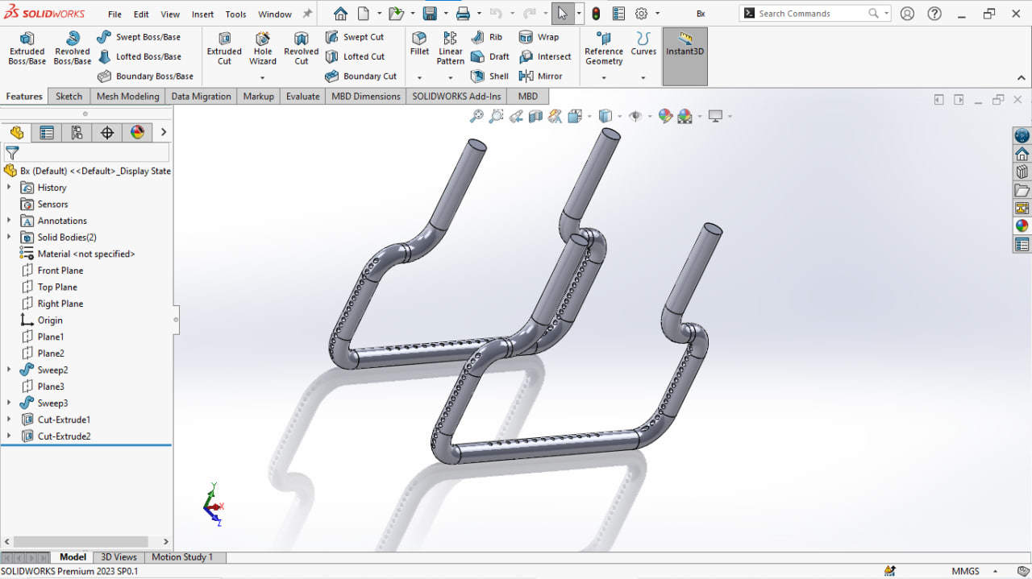
Figure 1.8

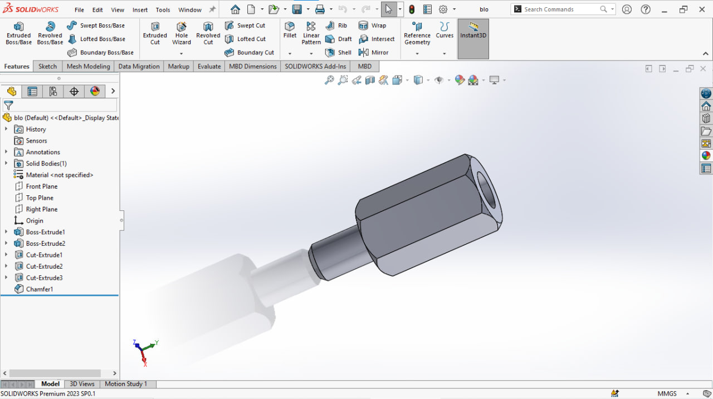
Figure 1.9

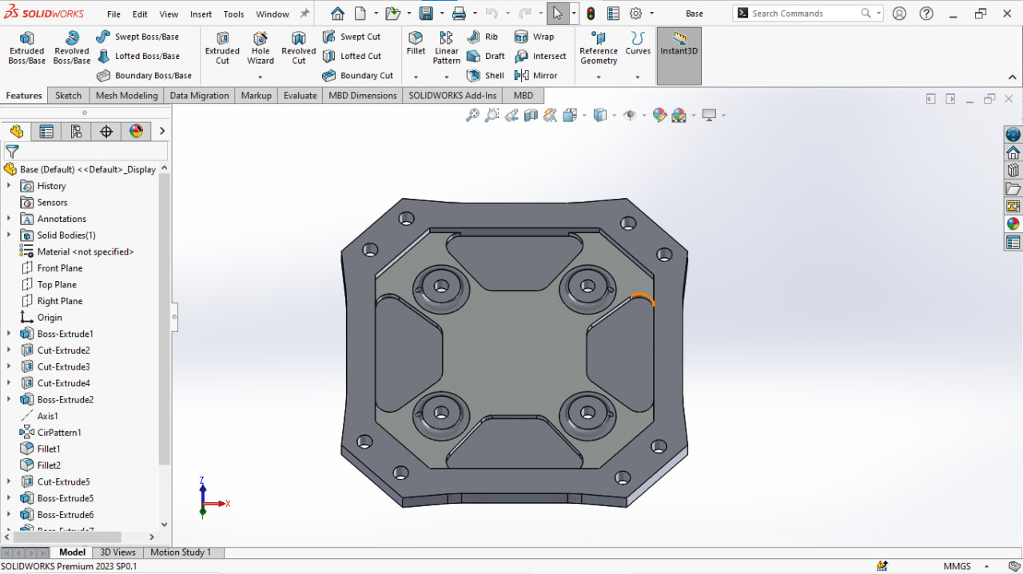
Figure 1.10

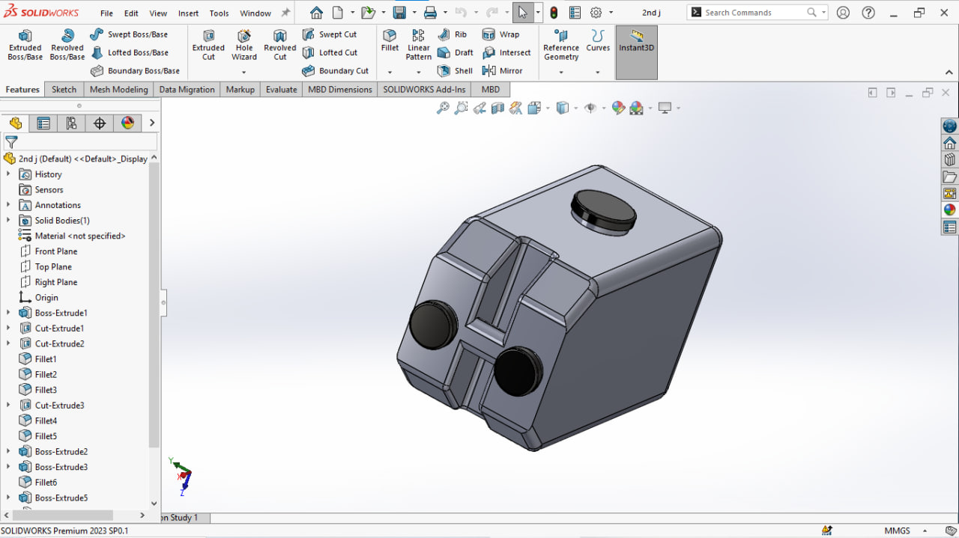
Figure 1.11

